EE106A/206A / BioE 125

Tic Tac Tobot

# Contact Information

|  |  |
| --- | --- |
| Name | Email |
| Nikolas Alberti | [nikolas.alberti@berkeley.edu](mailto:nikolas.alberti@berkeley.edu) |
| Patrick Scheffe | [p.s@berkeley.edu](mailto:p.s@berkeley.edu) |

# Project Proposal Abstract

The robot will control the movement of a whiteboard marker using two servos. First, it draws the playing field of Tic Tac Toe. A camera will be used for monitoring the player’s move (placing a circle or a cross). The robot will react and make its own move autonomously.

# Project Description

The robot will control the movement of a whiteboard marker using two servos. The pen will be set up in a construction which has two shoulder and two elbow joints, so it can be moved to a defined x-y-position. The two wrists are connected and the pen is mounted there. This makes it possible to move the pen with only two servos on the shoulder joints. The setup is shown in Figure 1. The whiteboard is mounted in a fixed position next to the manipulator.

First, the robot draws the playing field consisting of nine tiles. A camera will be used for monitoring the player’s move (placing a circle or a cross). Autonomously, the robot will react and make its own move. The actuation of the servo motors has to be planned in order to draw the desired shape. In order to make space for the human player’s moves, the whole construction should be able to move away from the field.

The basic idea of the robot can be seen in projects called ‘plotclocks’, where the robot writes the current time on a whiteboard. Our project incorporates sensing, an algorithm to play tic tac toe and an interaction with a human opponent.

# Tasks

1. Task 1: Build the robot
   1. Find the right dimensions of the robot arms (see Figure 2)
   2. Design the complete setup which connects
      1. Motors with arms and pen-lifting mechanism
      2. Whiteboard
      3. Camera
   3. Design the parts with AutoDesk Inventor
   4. 3D-Print the parts
2. Task 2: Code the robot
   1. Tic Tac Toe algorithm
   2. Identify crosses and circles with camera vision
   3. Map servo motor angles to pen positions
3. Task 3: Testing
   1. Basic actuation, robot can draw a cross
   2. Camera detects circles
   3. Robot can play Tic Tac Toe

# Milestones:

October 22: Training at the supernode maker space to get access to the 3D printers

October 26: The reverse kinematics map & sizing of the manipulator components

October 29: The mechanical components are completed

November 5: Having the actuation working

November 12: Having the vision working

November 19: The robot plays tic-tac-toe

November 22: *Project milestone report:* Get feedback on the performance

November 28: System tested

December 5: System improved, bugs fixed

December 9: Presentation, project video and report finished

December 15: Project presentation

# Assessment

The project is successful if the robot is able to play Tic Tac Toe against a human player. The most basic version is the case where the robot draws the playing field so that it knows where the nine tiles of the field are. The human player uses circles and the robot uses crosses.

When the basic functionality has been implemented and there is still time left, there are countless possible reach goals for this project. Especially the flexibility of the robot can be improved significantly. It may be possible to let the user draw a playing field and have the robot detect the tiles and calculate the end effector movement to draw the signs in the right space and of the right size accordingly. The robot could also detect which sign its opponent uses and decide to use a different one. It’s also imaginable that the robot detects when the user made a move and reacts after a delay when the user’s hand is out of the way. It’s possible that one should consider safety concerns, so that the robot does never move back onto the field while the users hand is still there. Basically it also is conceivable to implement another mode to let the robot draw or write.

# Team Member Roles

Nikolas’ background is in electrical engineering. He has an understanding of how to connect the components of the system. Patrick’s background is in mechanical engineering. He can model the robot components in CAD.

We will mostly work on the tasks together and split responsibilities up as it seems necessary during the project. It is often helpful to work as partners, as you make less mistakes.

# Bill of Materials

We plan to use one of the USB cams of the Robotics Lab.

We ordered the necessary equipment through the Introduction to Embedded Systems Class.

# Other

A sketch of the manipulator setup is shown in Figure 1. We modified the lengths of the robotic arms and looked for the parameters, for which the largest square fits inside the area the robot can cover. This is shown in Figure 2.

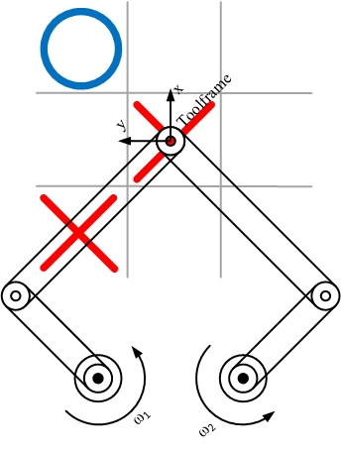

Figure : Manipulator Setup

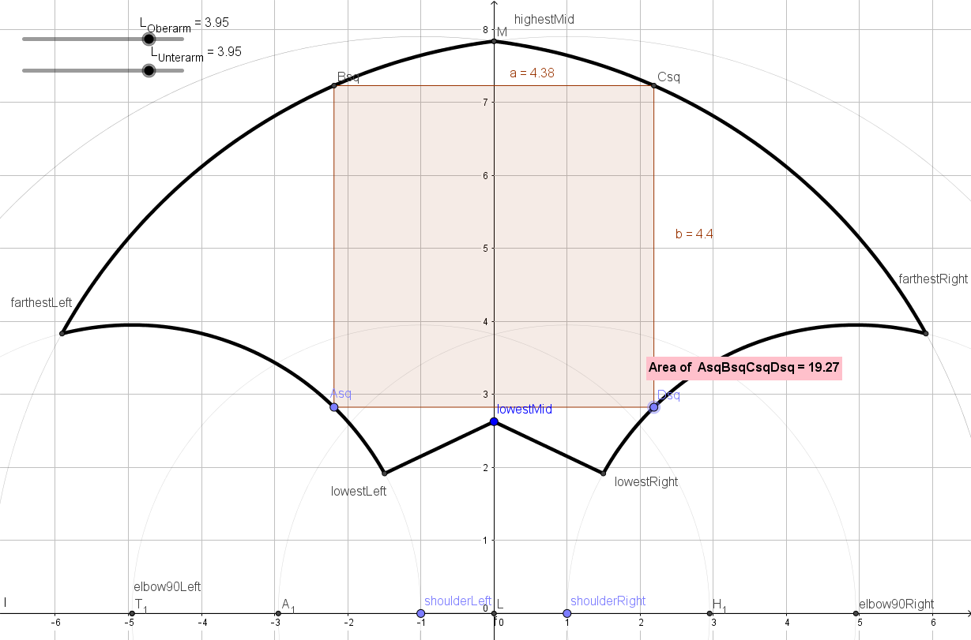

Figure : Manipulater Dimensions Design